  - calling notice

user group meeting 2
arona, italy
19-20 September 2013

Meeting Title: User Group 2
Date  19-20/09/2013 | Meeting Time | Meeting Location  JRC, Ispra, Italy
Meeting called by | Monique Heiligers, Gerard Temme (CertiFlyer)
Work Package | WP 6.3
Type of meeting | User Group Meeting
Facilitator | JRC
Prepared by | Monique Heiligers, Gerard Temme (CertiFlyer), Wietse Post (JRC)

Document Change Log
Version | Author(s) | Date | Affected Sections | Description of Change
1.0 | Monique Heiligers | 15/07/2013 | All

1 Invited ASCOS attendees 7
2 Invited other attendees (User Group Members) 7
3 Goals of the meeting 8
3.1 Thursday 19 September 8
3.2 Friday 20 September 8
4 Draft Agenda 9
4.1 Draft Agenda Thursday 19 September 9
4.2 Draft Agenda Friday 20 September 10
5 Prerequisites from participants 12
6 Meeting organisation 12
7 Logistics 12
7.1 Meeting venue 12
7.2 Registration 13
7.3 Dinner on Thursday 19 September 14
7.4 Reimbursement of travel costs for User Group members 14

Invited ASCOS attendees

Name | Organisation | Remark
Bernard Pauly | Thales Air System
Nuno Aghdassi | AVANSSA
Lennaert Speijker | NLR
Marga Martin Sanchez, Izaro Etxebarria | Isdefe
Veronique Bonvino, Jean-Pierre Heckmann | APSYS
Gerard Temme, Monique Heiligers | CertiFlyer
Alan Simpson | Ebeni
Andrzej Iwaniuk, Krzysztof Piwek | Institute of Aviation
Wietse Post | JRC

Maximum 15 ASCOS representatives will be present at the User Group Meeting.

Invited other attendees (User Group Members)
Name | Organisation | Remark
Ron van de Leijgraaf | CAA NL
Rob van der Boom | CAA NL
Piotr Michalak | CAO
Catherine Champagne | DASSAULT
Bruno Stoufflet | DASSAULT
Ken Engelstad | EASA
Tomasso Sgobba | ESA
Maite Trujillo | ESA
Keith Conradi | ESASI
Michel Piers | ESSI
Abdoulaye n’Diaye | EUROCAE
Eric Perrin | EUROCONTROL
John Lapointe | FAA
Tom Tessitore | FAA
Rudi den Hertog | FAST
Dieter Reisinger | IATA
Okko Bleeker | Rockwell
John Dalton | SAE
Patrick Mana | SESAR
Jos Nollet | SRC
Hendrik Schorcht | TUVN

Goals of the meeting

Thursday 19 September
To inform the user group members about the status of the ASCOS project. To present the results obtained to date in Work Packages 1, 2 and 3 with a focus on the following submitted deliverables:
- D1.1 Analysis of existing regulations and certification processes
- D1.2 Definition and Evaluation of innovative approaches to certification
- D2.1 Framework Safety Performance Indicators
- D2.2 Baseline Risk Picture Total Aviation System
- D3.1 Total Aviation Safety Assessment Methodology
- D3.2 Risk models and accident scenarios
The results obtained to date form the baseline for further discussion about the future work in ASCOS. The future work will be presented during the second day of the User Group Meeting (Friday 20 September).
To obtain information from the User Group about CATS, ECCAIRS and FAST relevant for the future work in the ASCOS project.

Friday 20 September
To present and discuss the future work in all work packages. To obtain input from the User Group members relevant for the future work.

Draft Agenda

Draft Agenda Thursday 19 September
9.00 – 9.30 | Registration
9.30 – 9.45 | - Welcome - JRC and Gerard Temme
9.45 – 10.15 | 2. General overview status ASCOS project – Lennaert Speijker  Form: presentation  Goal: To inform the user group members about the overall status of the ASCOS project.
10.15 – 11.15 | 3. Results Work Package 1 – Bernard Pauly  Form: presentation by WP1 leader followed by questions  Goal: To present the results obtained to date in WP1 with a focus on the following submitted deliverables  - D1.1 Analysis of existing regulations and certification processes  - D1.2 Definition and Evaluation of innovative approaches to certification
11.15-11.30 | Coffee break
11.30– 12.30 | 4. Results Work Package 2 – Nuno Aghdassi  Form: presentation by WP2 leader followed by questions  Goal: To present the results obtained to date in WP2 with a focus on the following submitted deliverables  - D2.1 Framework Safety Performance Indicators  - D2.2 Baseline Risk Picture Total Aviation System
12.30 -13.30 | Lunch
13.30-14.30 | 5. Results Work Package 3 – Veronique Bonvino  Form: presentation by WP3 leader followed by questions  Goal: To present the results obtained to date in WP3 with a focus on the following submitted deliverables  - D3.1 Total Aviation Safety Assessment Methodology  - D3.2 Risk models and accident scenarios
14.30– 15.15 | 6. CATS – (to be confirmed)  Form: presentation followed by questions  Goal: To inform the ASCOS team about (items related to) CATS relevant for the ASCOS project
15.15 – 15.45 | Coffee break
15.45 – 16.30 | 7. FAST – (to be confirmed)  Form: presentation followed by questions  Goal: To inform the ASCOS team about (items related to) FAST relevant for the ASCOS project
16.30 – 17.15 | 8. ECCAIRS – (to be confirmed)  Form: presentation followed by questions  Goal: To inform the ASCOS team about (items related to) ECCAIRS relevant for the ASCOS project
17.15 – 17.30 | 9. Evaluation – Gerard Temme  Form: plenary discussion  Goal: to evaluate whether the goals of the first day of UG meeting have been achieved
18.00 | Closure

Draft Agenda Friday 20 September
9.00-9.30 | Walk-in and coffee
9.30– 10.30 | 1. Future Work in Work Package 1 – Bernard Pauly  Form: short presentation by WP1 leader (15 min) followed by discussion and feedback  Goal: To present very briefly the scope of the future work in WP1 with a focus on the following on-going deliverables:  - D1.3 Development of new certification approach  - D1.4 Certification E-learning Environment  To obtain input from the User Group relevant for the future work.
10.30-11.00 | Coffee break
11.00 – 12.00 | 2. Future Work in Work Package 2 – Nuno Aghdassi  Form: short presentation by WP2 leader (15 min) followed by discussion and feedback  Goal: To present very briefly the scope of the future work in WP2 with a focus on the following on-going deliverables:  - D2.3 Process Safety Performance Monitoring  To obtain input from the User Group relevant for the future work.
12.00 -13.00 | Lunch
13.00 – 14.00 | 3. Future Work in Work Package 3 – Veronique Bonvino  Form: short presentation by WP3 leader (15 min) followed by discussion and feedback  Goal: To present very briefly the scope of the future work in WP3 with a focus on the following on-going deliverables:  - D3.3 Tools for risk assessment and user manual  - D3.4 Overall safety impact results and user manual  To obtain input from the User Group relevant for the future work.
14.00 – 14.30 | 4. Planned Work for Work Package 4 – Lennaert Speijker  Form: short presentation by WP4 leader (15 min) followed by discussion and feedback  Goal: To present very briefly the scope of the planned work in WP4. To obtain input form the User Group relevant for the Work Package.
14.30 – 15.00 | 5. Planned Work for Work Package 5 – Izaro Etxebarria  Form: short presentation by WP5 leader (15 min) followed by discussion and feedback  Goal: To present very briefly the scope of the planned work in WP5. To obtain input form the User Group relevant for the Work Package.
15.00 – 15.15 | 9. Evaluation – Gerard Temme  Form: plenary discussion  Goal: to evaluate whether the goals of the second day of UG meeting have been achieved
15.15 | Closure

Prerequisites from participants
All participants are required to register before 16 August 2013 as indicated in section 7.2 of this document.
Presenters are asked to prepare their presentations, keeping in mind the goal of the presentation and corresponding agenda item. Due to the full agenda and many interesting topics to cover, all presenters are urged to adhere to the time limits as indicated in the agenda, and to allow sufficient time for questions, feedback and discussion. Please send your presentation to Monique Heiligers (Monique.heiligers@certiflyer.eu) before Wednesday 28th August. The presentations will be sent to the User Group meeting participants prior to the meeting.

Meeting organisation
The second User Group meeting is jointly organised by Certiflyer and the Joint Research Centre (JRC).
The JRC will take care of all logistical aspects of the meeting such as registration, hotels, dinner on Thursday evening and reimbursement of travel costs for User Group members (see also section 7). The contact details of the JRC secretary are as follows: Ms. Adriana Cojocaru (Phone: +39-0332-785636; Fax: +39-0332-789156; Email: Adriana.COJOCARU@ec.europa.eu). Should you need further information, please do not hesitate to contact her.
Certiflyer will take care of the technical contents of the User Group meeting such as agenda, presentations, discussions, etc. If you have any questions or remarks, please contact Monique Heiligers (Monique.heiligers@certiflyer.eu, +31 6 211 57 174).

Logistics

Meeting venue
The second User Group meeting will take place in the Atlantic Hotel in Arona, Italy. Arona is located approximately 30 kilometres from Milan’s Malpensa Airport at the east coast of the Lake Maggiore.
Free bus transport is arranged by the JRC from Malpensa Airport to Arona departing at 20:00 on Wednesday 18 September and back from Arona to Malpensa Airport departing from the meeting place at 15:30.
Hotel Atlantic
corso Repubblica 124
28041 Arona NO Italy
Tel. 0322 46521
Fax 0322 48358
http://www.atlanticarona.com/

Registration and hotel reservations
The practical organisation of this meeting is done by the JRC. All participants are kindly requested to register as soon as possible via their meeting registration web site
https://jrc-meeting-registration.jrc.ec.europa.eu/
After logging in to the meeting registration application you can find this meeting under the TAB “Other Locations” for the month of September 2013, as can be seen from the figure below.

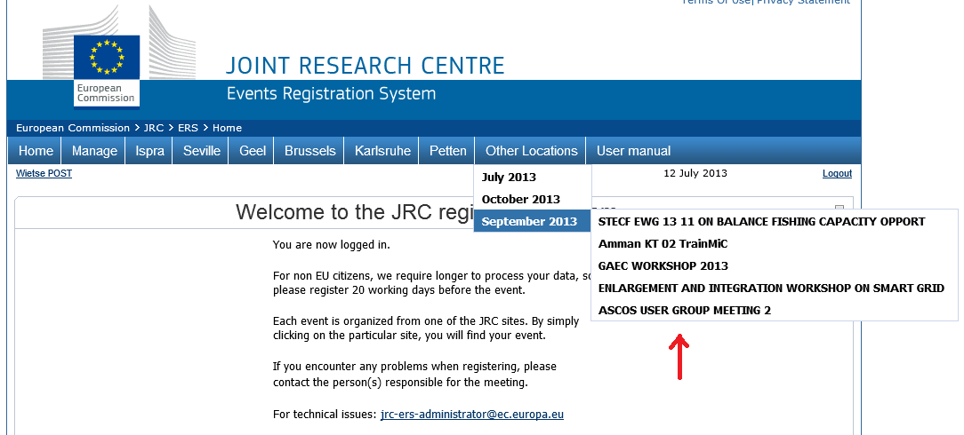

The deadline for registration to the meeting is 16 August 2013 and will need to be respected strictly. The number of places available for the meeting is limited to 30. The meeting will take place in hotel Atlantic in Arona.
The JRC have reserved sufficient hotel rooms divided between Hotel Atlantic (single room 100,50 Euro) and Hotel Giardino (single room 77 Euro) double rooms are available at a higher rate. Hotel Giardino is about 200 meters away from Hotel Atlantic; normally the weather in September is nice. During your registration you can indicate if you want to profit from the special rates of one of the two hotels. You can also indicate in which of the two hotels you prefer to book a room. There is no need to contact the hotel directly; the JRC will pass the reservations to the hotel.
The registration procedure will ask for a registration code. The registration code for this meeting is
ASCOS2013

Dinner on Thursday 19 September
Thursday evening a social dinner will be arranged for all User Group meeting participants.

Reimbursement of travel costs for User Group members
User Group members (maximal 15) will have the possibility to claim reimbursement of their travel and accommodation allowance. ASCOS will be able to reimburse the Travel and subsistence of at most 1 person per organization, participating in the User Group. According to the ASCOS contract with the European Commission, the maximum amount to be reimbursed is 1000 euro per travel. In order to be able to reimburse travel costs, user group members should register at the latest on 16 August 2013, such that the JRC can send a formal invitation letter before the meeting.

